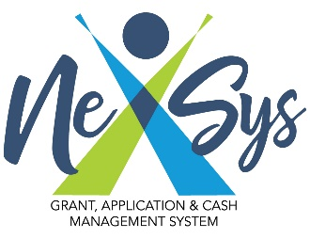
Quick Guide to Budgets

Creating a Budget:
- Select Review Grant Selections under the Forms section of the sliding menu.
- Select Apply Now to initiate the budget page.

Budget Summary:
- Displays a summary of all budget items.
- Budget detail items rolled up to the Function Code “10” level.
- Includes entry box for Indirect Costs, if permitted.
- Complete required Program Contact information located at the bottom of the Budget Summary.
- Click Save.
- A link to a report of all the Budget Item Detail appears within the Budget Summary.

Creating Budget Items:
- Click Budget Items.
- Complete Budget Detail item detail fields accordingly, click Save.
- To Add another budget item click Add in the upper right-hand corner of the screen.
- Shaded area outlines Flag Budget Item detail. This section is only available to MDE review consultants. Once the application is reviewed the consultant may choose to use this feature to indicate whether the budget item is Approved, Modifications Required or Unallowable.
- If you click the Ü next to Budget Items in the scrolling menu, a pop out menu will appear that will display budget items. Users can click a budget item for direct access to review or update.
- To add a budget item if you have left the Budget Items page, click any budget item from the slide out menu, then click Add.

Budget Errors:
- Applications may be prohibited from being submitted if budget errors exist.
- Review the errors presented, update and save budget and budget items accordingly.

